Day 5
Network testing Practical
1.Connect your laptop and a friend's phone to the same Wi-Fi network, then use the ping command to check if both devices can communicate with each other.
Aim
To test whether a laptop and a friend's phone connected to the same mobile hotspot can communicate with each other using the ping command.
Requirements
- Windows laptop
- Mobile phone with hotspot enabled
- A second phone connected to the hotspot
- Windows Command Prompt (CMD)
Procedure
Step 1: Connect both devices.
Turn on the mobile hotspot on one phone and connect your laptop and your friend's phone to it.
Step 2: Find the laptop's IP address.
Open Command Prompt and type: ipconfig
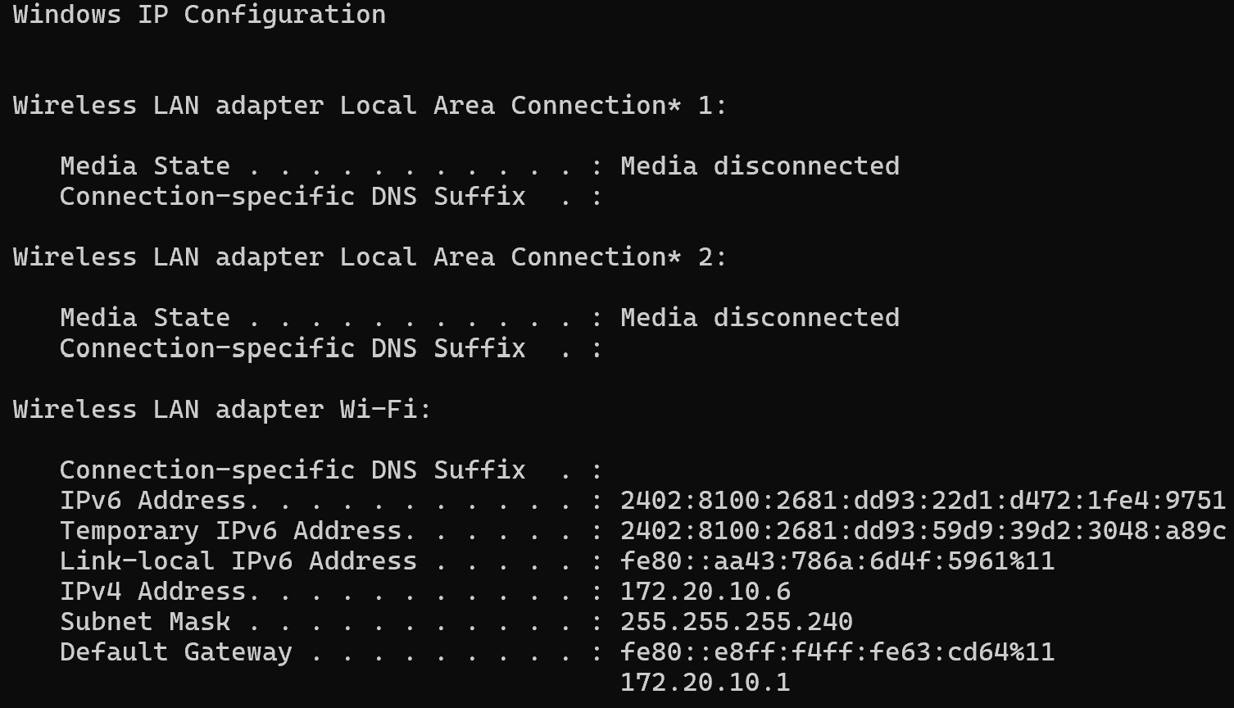
Step 3: Find your friend's phone IP address.
Open the connected Wi-Fi network details on your friend's phone and look for its IP address.
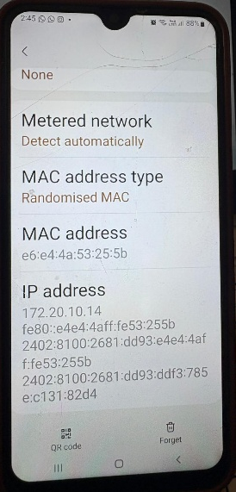
Step 4: Run the ping command.
In Command Prompt, enter the phone's actual IP address:
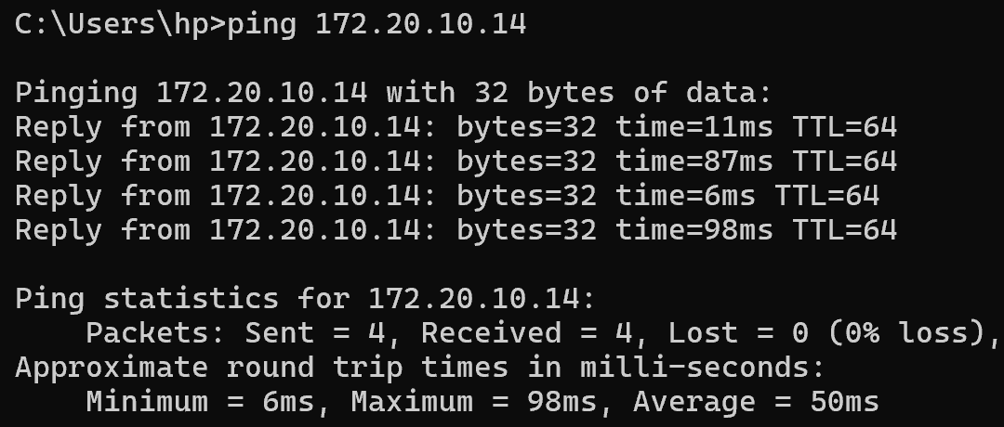
- Reply from: A response was received from the destination.
- Time: The time taken for the response, measured in milliseconds.
- TTL: The remaining packet lifetime value.
If the output says Request timed out, the phone may be blocking ping requests, or communication between devices may be restricted by the mobile hotspot.
Observation
Record the actual result from your test:
- Successful: Replies received from the destination phone.
- Unsuccessful: Request timed out or another error message appeared.

Result
The ping command is used to test network reachability between devices. When both devices are connected to a mobile hotspot, the test may succeed or fail depending on hotspot settings and device restrictions.
Quick revision notes
Term | Meaning
ping | Tests whether a destination device is reachable.
ipconfig | Displays network configuration on Windows.
IPv4 address | Identifies a device on an IP network.
Default gateway | The device that provides a route to other networks.
Request timed out | No reply arrived within the allowed time.
Important: Because you are using a mobile hotspot, you do not need a separate home Wi-Fi router. Also, pinging the default gateway tests the hotspot connection, whereas pinging your friend's phone tests device-to-device communication. These are two different tests.

2.Run the traceroute (tracert on Windows or traceroute on Mac/Linux) command to www.youtube.com from your device and note down the number of hops it takes to reach the destination.
traceroute (tracert) is used to find the path that data takes from your device to another device or website across a network.
What is traceroute used for?
- Identify network hops: Shows the intermediate routers that data passes through on its way to a destination.
- Troubleshoot network problems: Helps identify where a connection may be slowing down or failing.
- Measure delays: Displays the response time at each hop, usually in milliseconds (ms).
- Understand network routes: Helps network administrators investigate how devices connect across different networks.

Example
When you run this command on your Windows laptop:
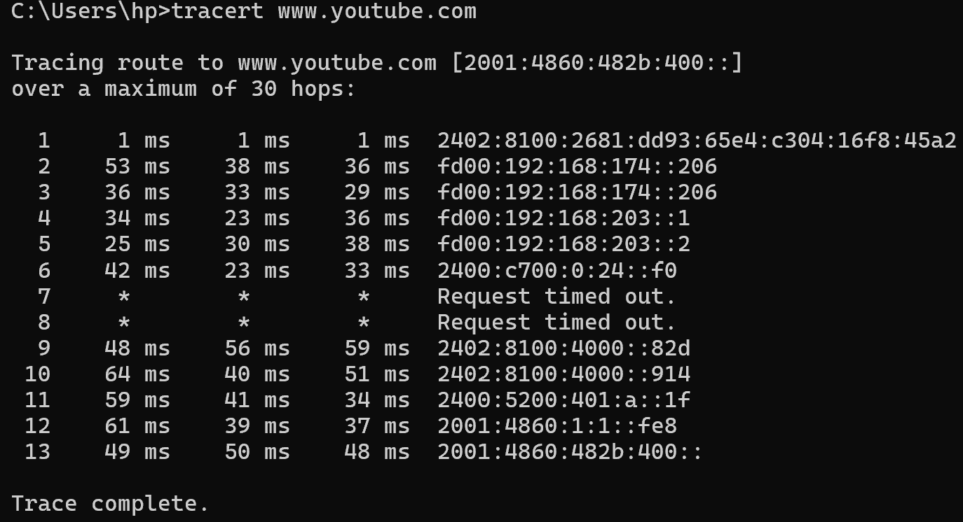
Traceroute is a network command that shows the path data takes from your laptop to a website through different network devices called routers.
Command used (Windows):
tracert www.youtube.com
Your observation: The command displayed 13 hops before completing the trace to YouTube. Hops 7 and 8 showed request timeouts, meaning those devices did not respond to the probes.
Result: Traceroute helps us understand the route to a website and identify possible network delays or connection problems.
Remember: ping checks whether a destination responds, while tracert shows the route taken to reach it.

3.Disconnect one device from the Wi-Fi, then try pinging it again from your laptop and describe the error message you receive.
Aim
To observe how the ping command behaves when a device is disconnected from the Wi-Fi network.
Procedure
- Connect your laptop and your friend's phone to the same mobile hotspot.
- On your laptop, open Command Prompt (CMD).
- Ping your friend's phone using its IP address:
ping 172.20.10.14
- Disconnect your friend's phone from the mobile hotspot.
- Run the same ping command again and observe the output.
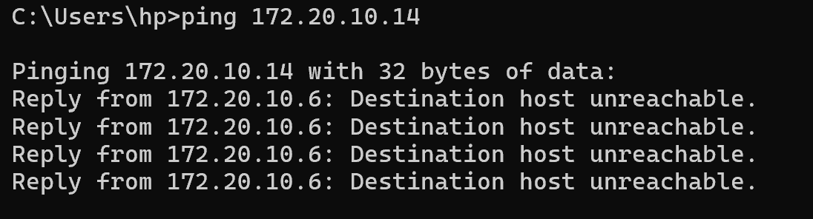
Explanation: This message means that the laptop did not receive a reply from the phone within the allowed time. The phone may be disconnected, or the hotspot may block ping requests.
Result
After disconnecting the phone from the mobile hotspot, the ping command may display Request timed out or another error message because the phone is no longer reachable at its previous network address.
Important: Record the actual message you receive. A disconnected phone may later receive a different IP address when it reconnects, so check its current address before testing again.

4.Create a simple table listing the IP addresses of all devices connected to your home Wi-Fi (use 'arp -a' on Windows), and identify which device belongs to which person or gadget.
Aim
To display IP and MAC addresses of devices recently identified on the local network and identify the corresponding devices where possible.
Procedure
Step 1: Connect your laptop to your mobile hotspot.
Step 2: Open Command Prompt by pressing Windows + R, typing cmd, and pressing Enter.
Step 3: Enter this command:
arp -a
Step 4: Press Enter. Windows displays the ARP table, which contains IP addresses and their associated MAC addresses that your laptop has learned.
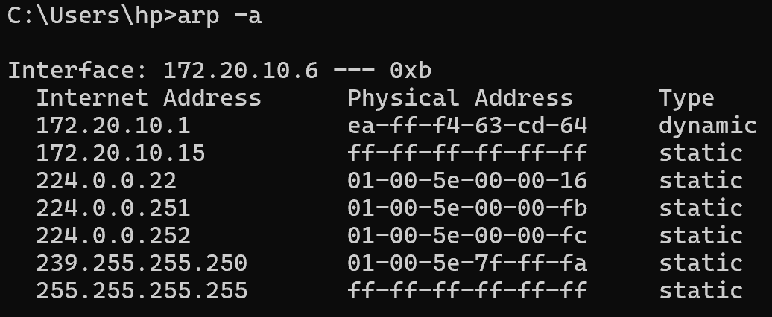
The arp -a command displays your laptop's ARP table, which maps known local IPv4 addresses to their corresponding MAC addresses.
A MAC address is a hardware-level network identifier associated with a network interface.
Important: Your screenshot does not show your friend's phone at 172.20.10.14. This is not necessarily an error; your laptop may not have a current ARP entry for that phone, particularly after it disconnected.

What is the practical use of arp -a?
- Helps troubleshoot local network communication.
- Shows known IP-to-MAC address mappings.
- Can help investigate which local devices your laptop has communicated with.
It does not reliably list every device connected to your hotspot.

5.Write a one-page report explaining step-by-step how you set up the network, tested connectivity using ping and traceroute, and what results or issues you observed.
Report on Setting Up and Testing a Basic Network
1. Objective
The objective of this practical was to establish a network connection, test communication between devices using the ping command, trace the route to a website using tracert, and examine local network address information using arp -a.
2. Network Setup
I enabled a mobile hotspot and connected my Windows laptop and my friend's phone to it. I used the ipconfig command in Command Prompt to check the laptop's network configuration. The laptop's IP address was 172.20.10.6, while my friend's phone had the IP address 172.20.10.14.
3. Connectivity Test Using Ping
I executed the command ping 172.20.10.14 to check whether my laptop could communicate with my friend's phone. The output showed four replies, with four packets received and zero packet loss. The average response time was 50 ms, indicating successful communication.
Next, I disconnected my friend's phone from the hotspot and repeated the ping test. The output displayed "Destination host unreachable", indicating that my laptop could not reach the phone at its previous IP address.

4. Route Tracing Using Tracert
I executed tracert www.youtube.com to examine the network route from my laptop to YouTube. The command traced the route using IPv6 and displayed 13 numbered hops before completing. Hops 7 and 8 showed request timeouts, but subsequent hops responded and the trace completed successfully.

5. Examining Network Addresses
I used the arp -a command to view the laptop's ARP table, which displays known mappings between local IPv4 addresses and MAC addresses. The output included the address 172.20.10.1, likely the hotspot gateway. The command did not display every connected device.

6. Conclusion
This practical demonstrated how to test connectivity using ping, examine network routes using tracert, and inspect local IP-to-MAC address mappings using arp -a. The successful ping confirmed communication between the laptop and the phone while connected to the hotspot. Disconnecting the phone resulted in a destination-unreachable message, demonstrating how network availability affects communication.

